

# **FINAL REPORT**



## **Group Members:**

## Yatharth Deoly

## Donkanna Jagannath

## Itishree Dash Senapati

## Rushikesh Upadhyay

Table of Contents

Summary of problem statement, data and findings 3

Summary of the Approach to EDA and Pre-processing 6

Deciding Models and Model Building 7

How to improve your model performance 9

Overview of the final process 10

Step-by-step walk through the solution 11

Model evaluation 14

Python Flask and React Application 19

Comparison to benchmark 21

Closing Reflections 21

# **Summary of problem statement, data and findings**

Stanford car dataset has been provided to design car identification model.

This dataset comprises of different formats of input i.e.,

Car Images.zip(Contains all the images of car)

Annotations.zip(Contains bounding-box coordinates of car image)

Car names and make.csv(Contains 196 unique car names with their build year).

Dataset contains 16,185 images which is split into 8,144 training images and 8,041 testing images, where each class has been split in a 50.31% training and 49.68% testing.

On the basis of images need to train model which will classify any new test car image as one of the car names from 196 unique class.

Let’s define each input dataset:

1. “Car names and make.csv”:
   1. Sample of data present in given csv file

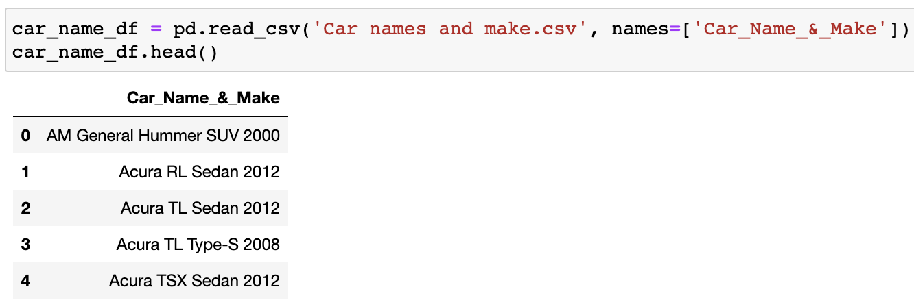

* 1. Dataset dimension:

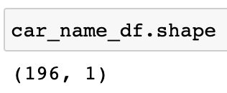

1. “Annotations.zip”:
   1. Extract all data from zip achieve, which contains ‘Train Annotations.csv’ and ‘Test Annotation.csv' files.
   2. These csv file contains bounding box region for both train and test images.
   3. ‘Train Annotations.csv’, sample of data present in given csv file:

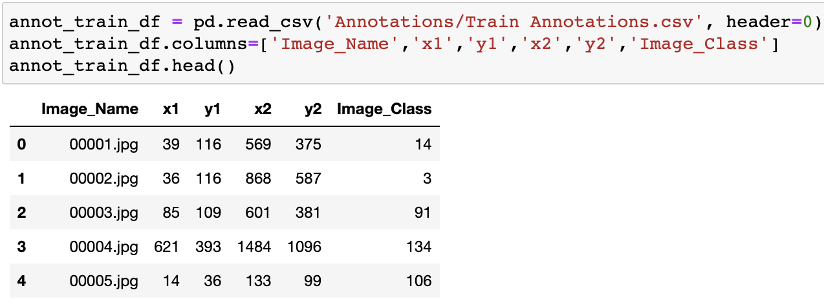

* 1. Dimension of train annotations dataset:

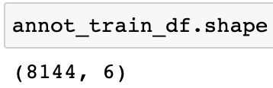

* 1. ‘Test Annotation.csv', sample of data present in given csv file:

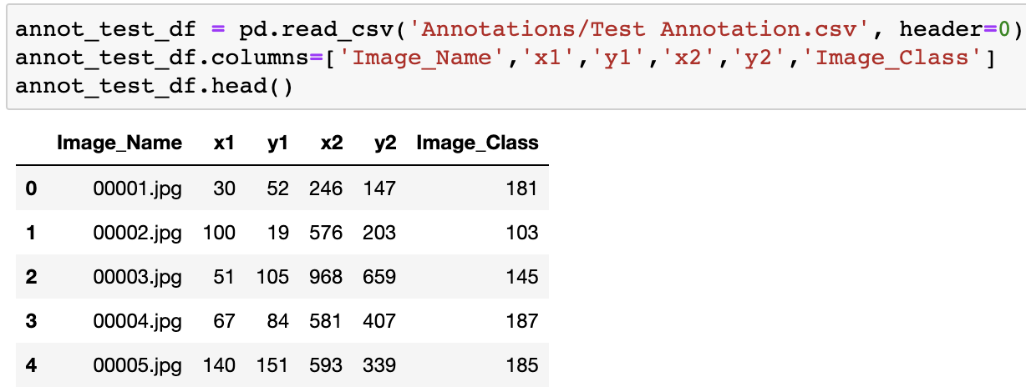

* 1. Dimension of test annotations dataset:

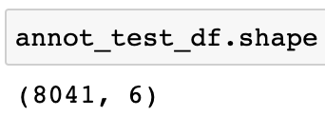

1. “Car Images.zip”:
   1. Extract all data from zip achieve, which contains ‘Train Images’ and ‘Test Images’ folder. Images are in RGB channel.
   2. Sample train images:

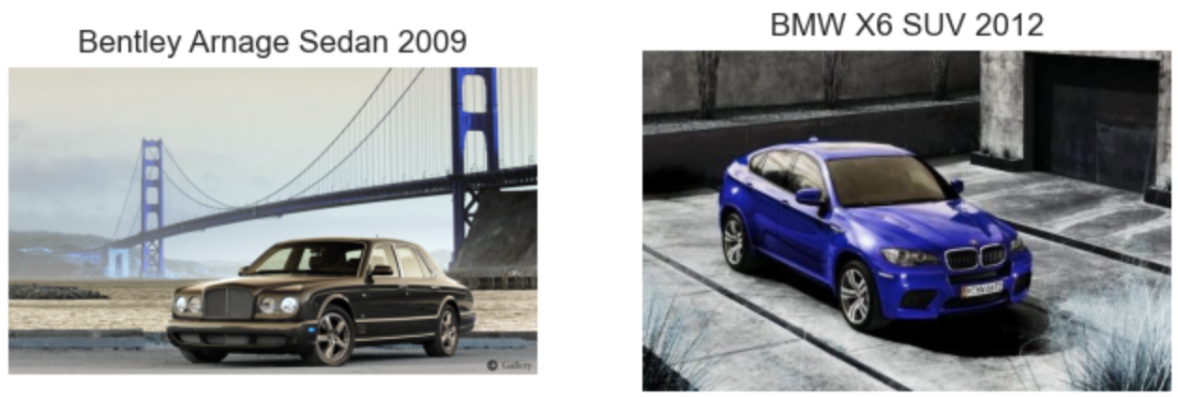

* 1. Sample test images;

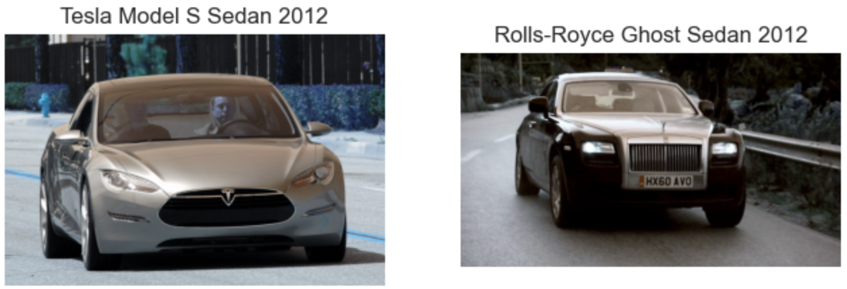

Sample images with bounding boxes:

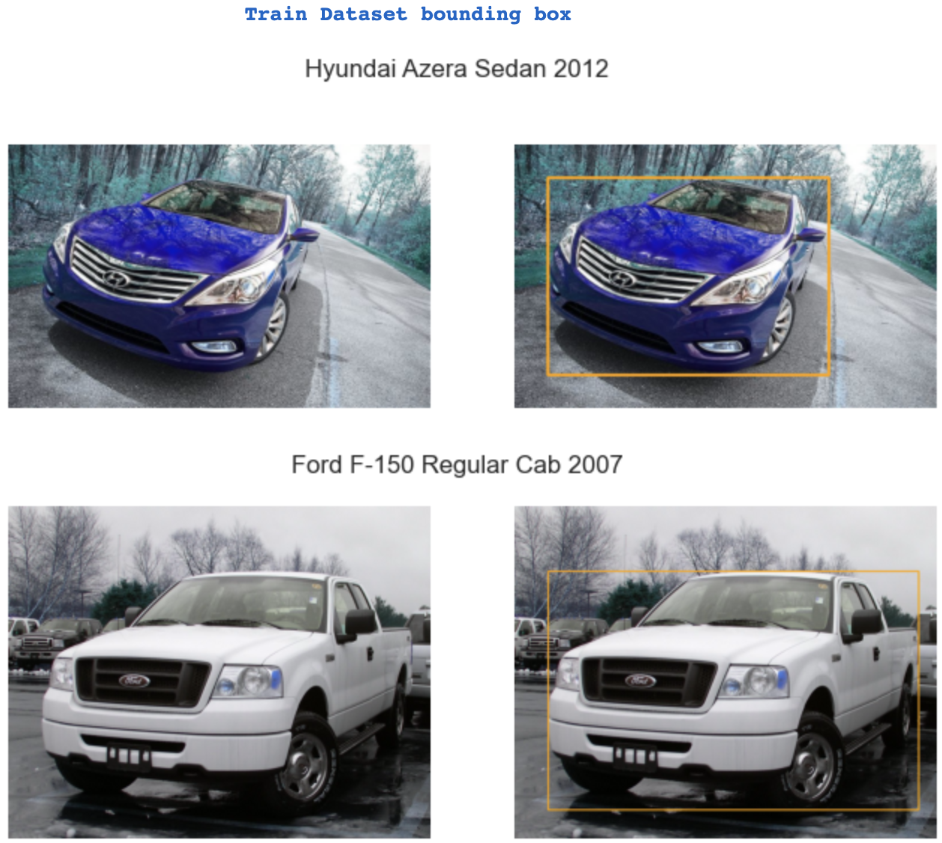

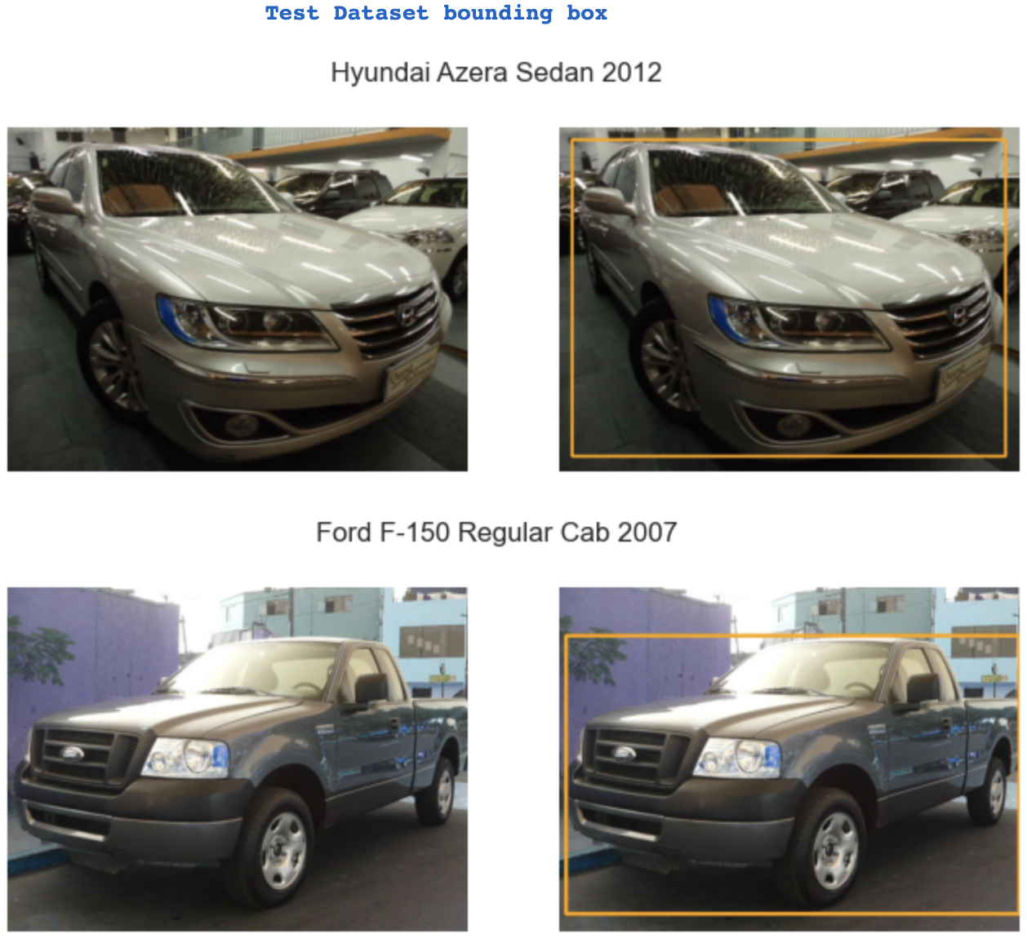

# **Summary of the Approach to EDA and Pre-processing**

* As images provided are having different aspect ratio or height and width, so just to minimise the irrelevant data, have cropped the images using the boundary-box and extra margin of 15 spaces.
* As images were provided, so extracted them to matrix format.
* Unified all images to same height(224) and width(224) and then normalized pixels.

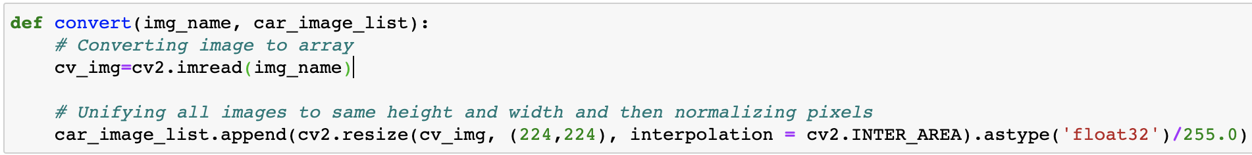

* Encoded target using labelEncoder after which categorised using keras package.

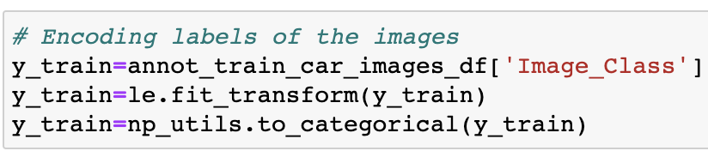

* Car name distribution:
* Training set distribution: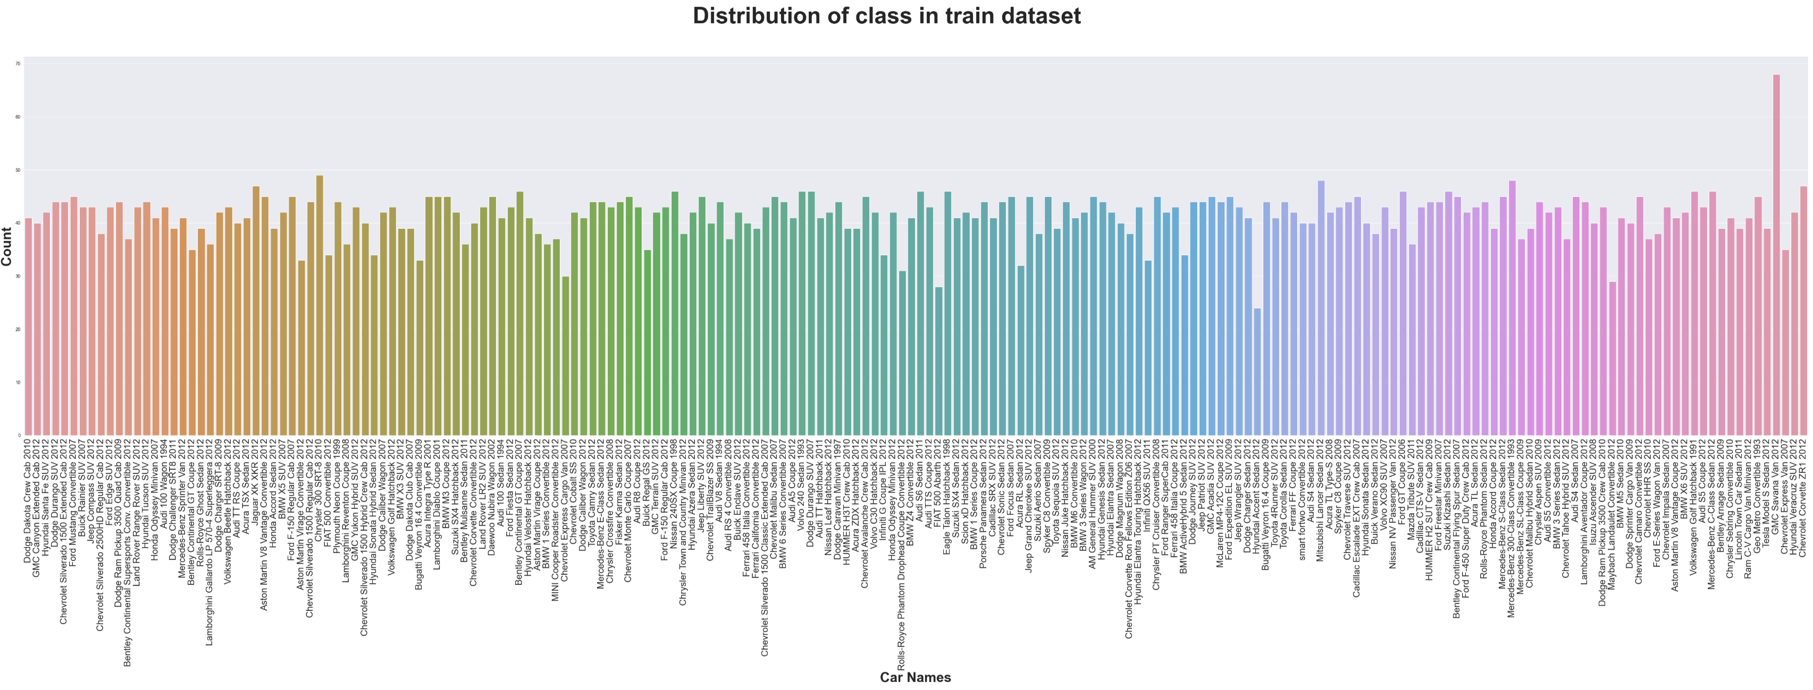
* Testing set distribution: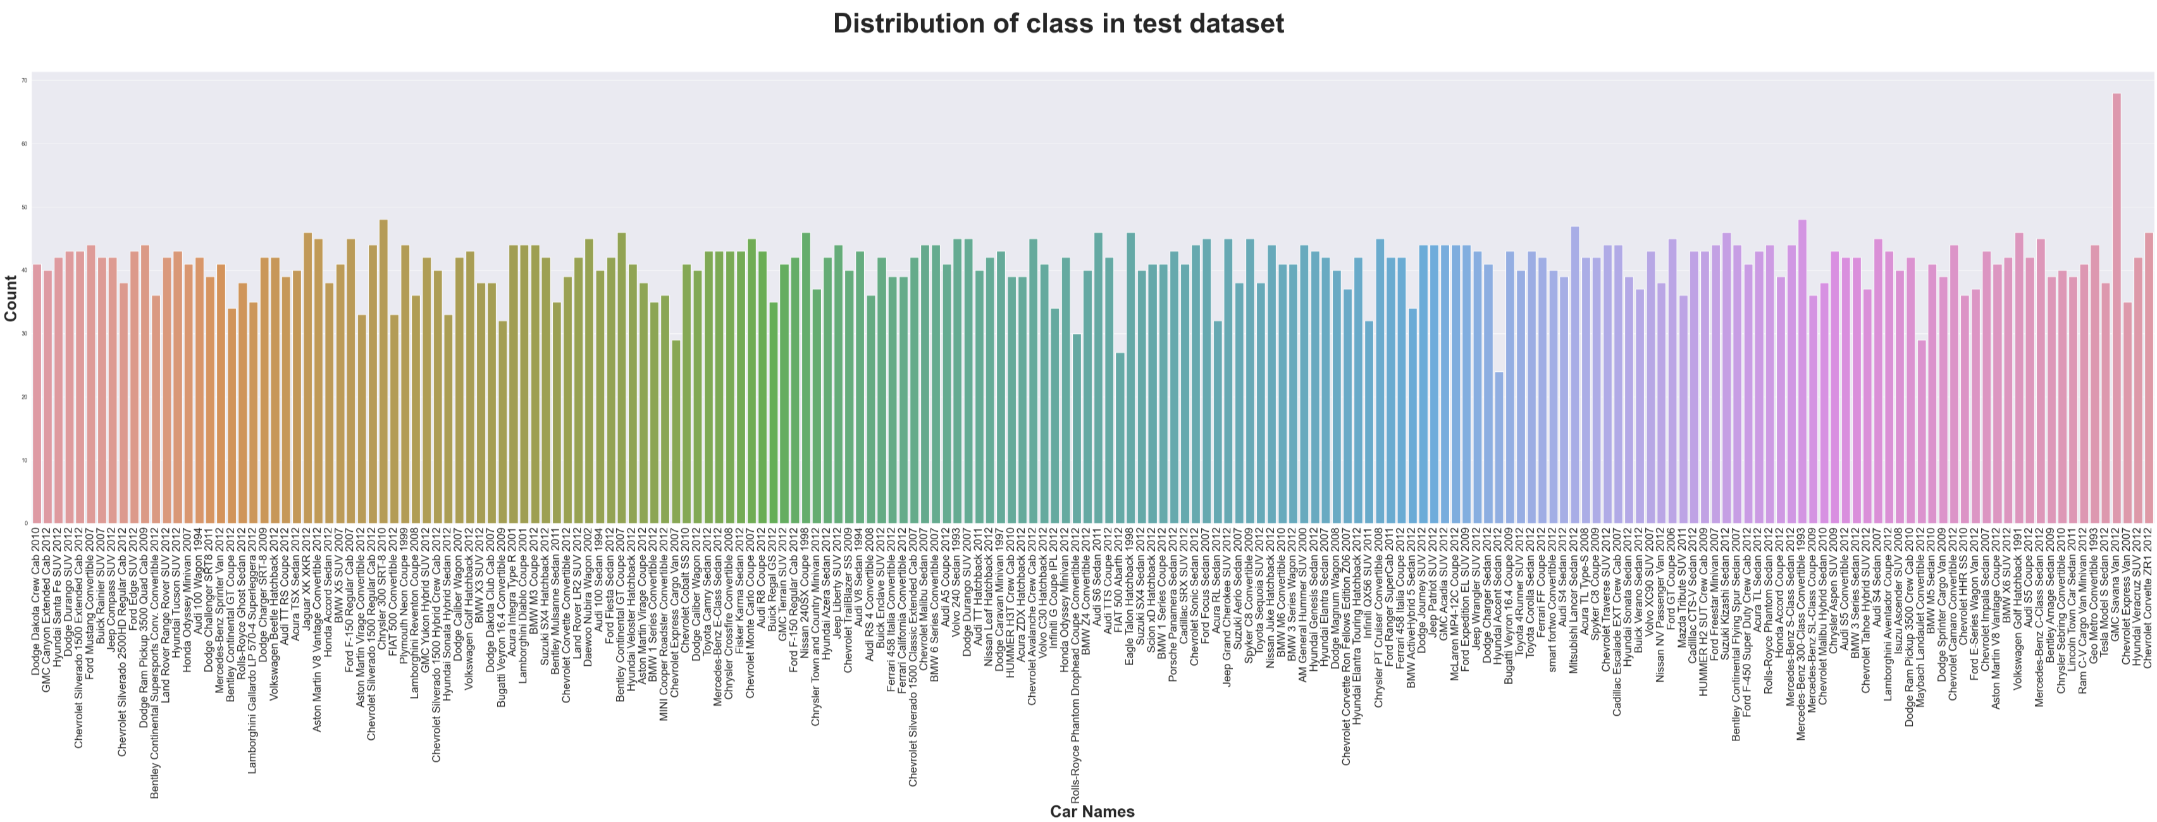

# **Deciding Models and Model Building**

As the provided problem statement requirement is to identify car model on the basis of input image. Currently set of images have been provided on the basis of which we will train our model so that it can be used as car identification model.

So this type of model training comes Computer Vision where we will be making models from scratch and on the basis of that we will use other models.

In this milestone we will be using light models as training models can take ample time and because of resource constraint also, will be going for 2 shallow models and 1 deep model.

All models by default will be using ‘Adam’ as optimizer with call-backs functions as ‘EarlyStopping’, ‘ModelCheckpoint’ and ReduceLROnPlateau’

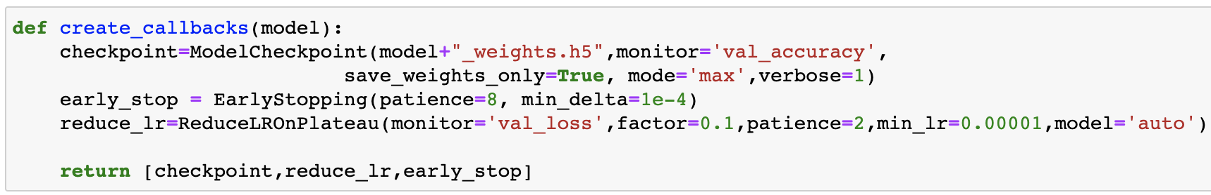

As models were taking ample time so have pickle the model for future usage.

Types model used are:

1. CNN with Architecture as : 3 Conv + 2 Avg pooling + 1 FC layer + 1 FC-SoftMax layer
   1. Model summarised:

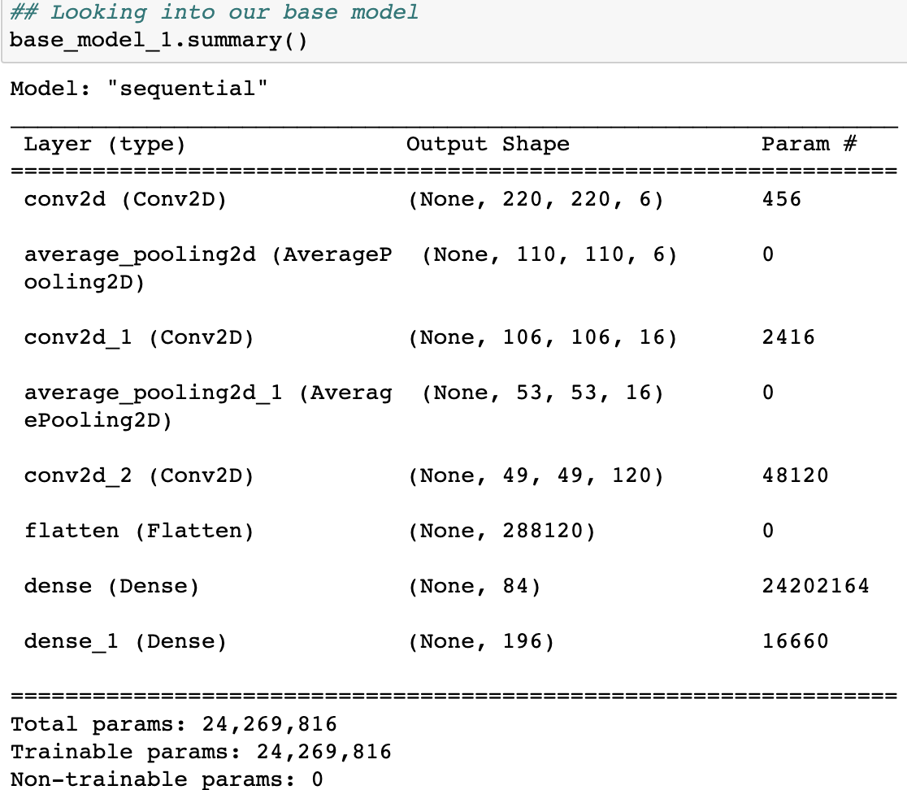

* 1. Model summarised using visual keras package:

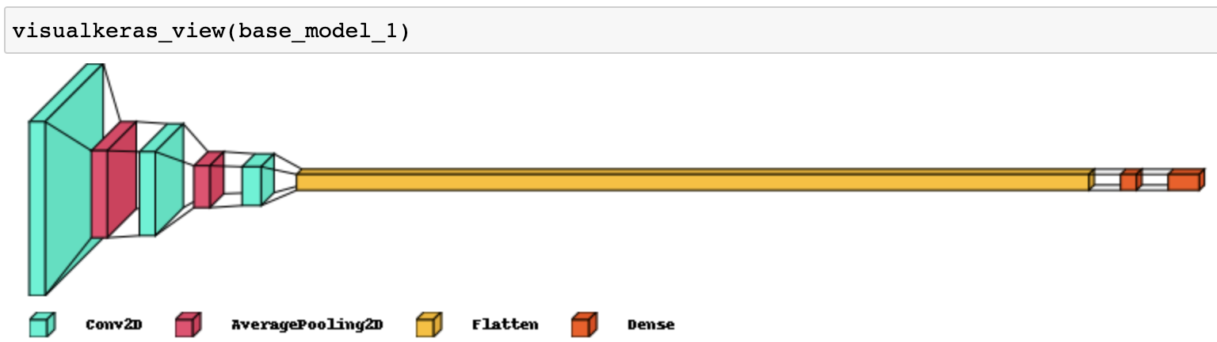

* 1. Model has been trained with 20 epochs and 50 batch size.
  2. Training Accuracy: 0.8409 with loss: 0.7045.
  3. Testing Accuracy: 0.0271 with loss: 9.8769.
  4. This model didn’t worked well, will be checking for other models.

#### CNN with Architecture as : 5 Conv + 3 Max Pool + 2 FC layers + 1 FC-SoftMax layer

* 1. Model summarised:

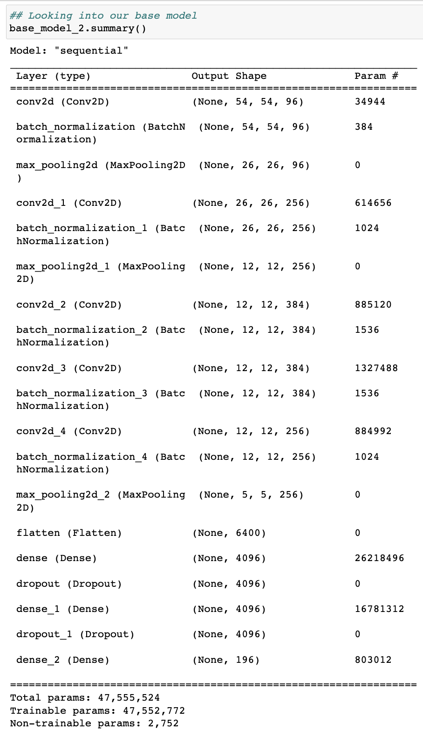

* 1. Model summarised using visual keras package:



* 1. Model has been trained with 50 epochs and 50 batch size.
  2. Training Accuracy: 0.6720 with loss: 1.6347.
  3. Testing Accuracy: 0.1970 with loss: 3.6971.
  4. This model didn’t worked well, will be checking for other models.

1. CNN with Architecture as : ResNet50 deep layer
   1. Model summarised, only last part attached, as this model is a deep layer model.

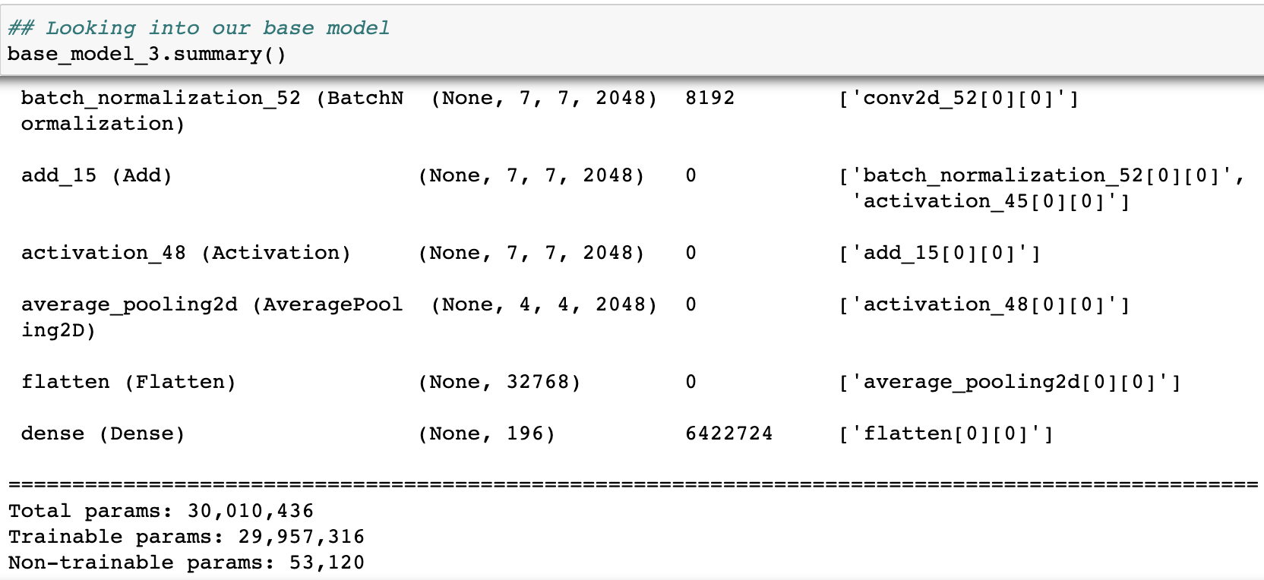

* 1. Model has been trained with 20 epochs and 50 batch size.
  2. Training Accuracy: 0.6720 with loss: 1.6347.
  3. Testing Accuracy: 0.1970 with loss: 3.6971.
  4. This model didn’t worked well, will be checking for other models.

# **How to improve your model performance**

Let’s compare scores for models trained from scratch.

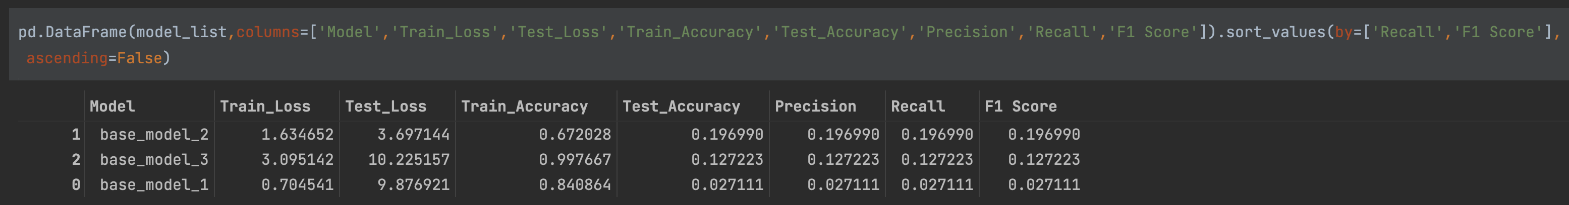

Concluding what all things we can do to improve our model performance:

* Neural networks rely on loads of good training data to learn patterns from dataset. So we can apply image augmentation to increase dataset size by rotating, zooming, cropping and more pattern.
* As our model seems to be overfitting for some case, we can lower the learning rate so that at lower epochs model don’t achieve overfitting.
* Reshuffling the training data in between epochs can help model to understand dataset in different manner for every epochs.
* As we are developing model from scratch because of which training is taking much time. So for this we can use transfer learning and can use pre-trained models with pre-trained weights, just by changing some layers. We can use models like, EfficientNet-B4, MobileNet, ResNet-152 and more.
* We can use K-Fold Cross-Validation, which will divide the images into K parts of equal size and then train the model K number times with different training & validation set.

# **Overview of the final process**

* In milestone-1, we have achieved model training with some EDA, data pre-processing and data visualisation. In this milestone-2 we will focus more over improvising models and using different transfer learning mechanism.
* As we have less data, we will be using image augmentation technique to increase dataset size by rotating, zooming, cropping, flips and more patterns.
* Once we have good amount of training dataset, we will be doing hyper-parameter tuning for the previous best model. Hyper-parameter tuning will include increase in dense layer with Dropout and BatchNormalization, increasing learning_rate with different optimizers, changing epochs, steps_per_epoch and more.
* Next step we will be training model using transfer learning mechanism where we will use ‘MobileNetV2’ as base model with weights of 'ImageNet'. After some changes over base model, we will train our model.
* So basically till now we were just classifying the images, now we will train models for defining boundary boxes with image classifier.
* To know more better for bbox and image classification, we will be using existing model i.e., ‘faster_rcnn_nas_coco_2018_01_28’ which is pretrained with coco dataset. So using this pre-trained model with our dataset and will check for results.
* Using transfer learning on ‘MobileNetV2’ we will train a model which will be resulting boundary box and class label. So for that, we will construct pre-model layers with some new modelling layer. As this model will be providing 2 details so accuracy check will also improvise.
* As all above models will be pickled or saved for future use, so we will make an flask and react application where user can upload image and will get result with boundary box and class label printed on uploaded image.

# **Step-by-step walk through the solution**

1. **Image Augmentation**

As neural networks rely on loads of good training data to learn patterns from dataset. So we applying ImageDataGenerator to get different set of images for train and test dataset that can be used for further model training.

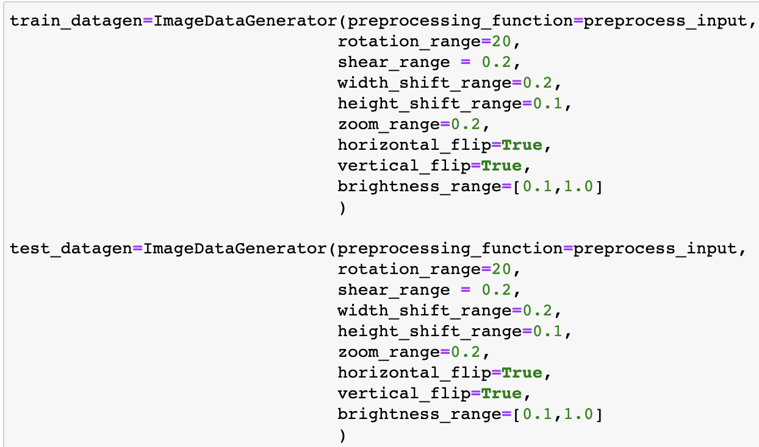

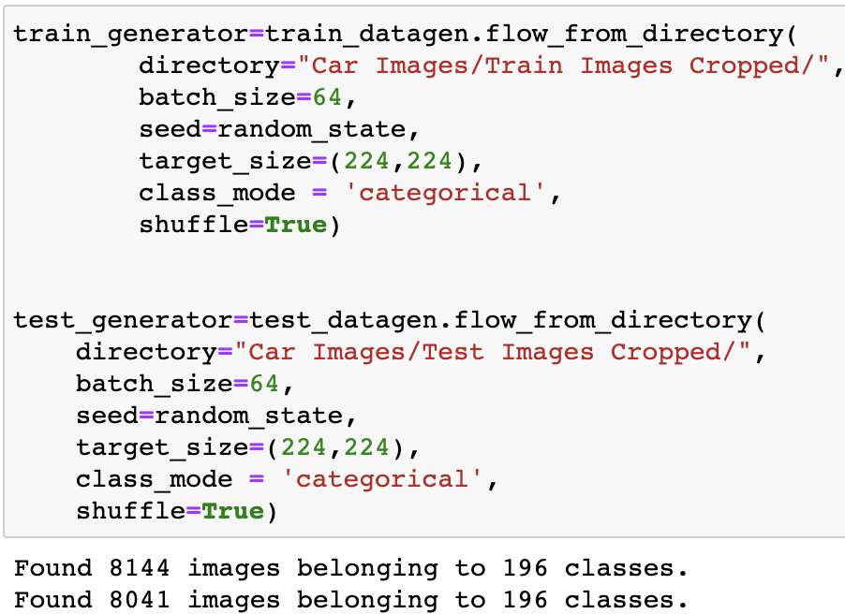

1. **Tuning old scratch model**

CNN with Architecture as : 5 Conv + 5 Max Pool + 2 FC layers + 1 FC-SoftMax layer

1. Model Summary:

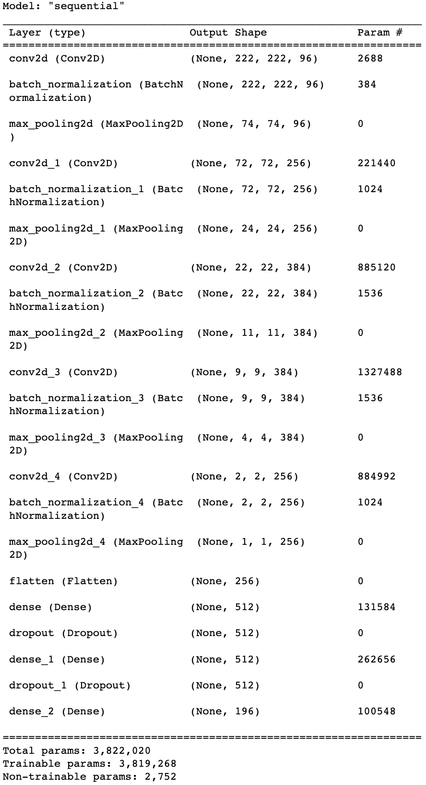

1. Model summarised using visual keras package:

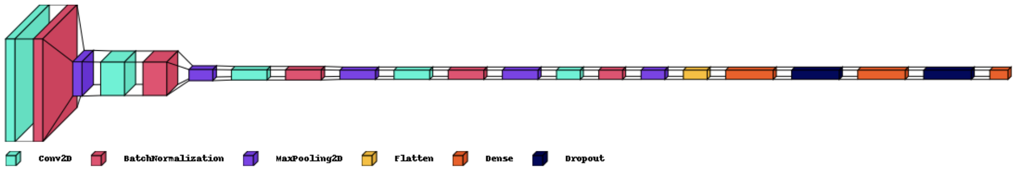

1. Model has been trained with 50 epochs, 100 steps_per_epoch, and 50 validation_steps with fit_generator.
2. Training Accuracy: 0.0323 with loss: 5.0460.
3. Testing Accuracy: 0.0298 with loss: 5.0862.
4. This model tuning didn’t worked well, will be checking for other models.
5. **Initializing MobileNet CNN with Architecture using transfer learning**
6. Base model as MobileNetV2 with input_shape as (224,224,3) and weights as ‘ImageNet’.
7. Defining user model over the base model with starting 70 layers as not trainable and adding dense layer with 196 as SoftMax output.
8. Model summary trimmed:

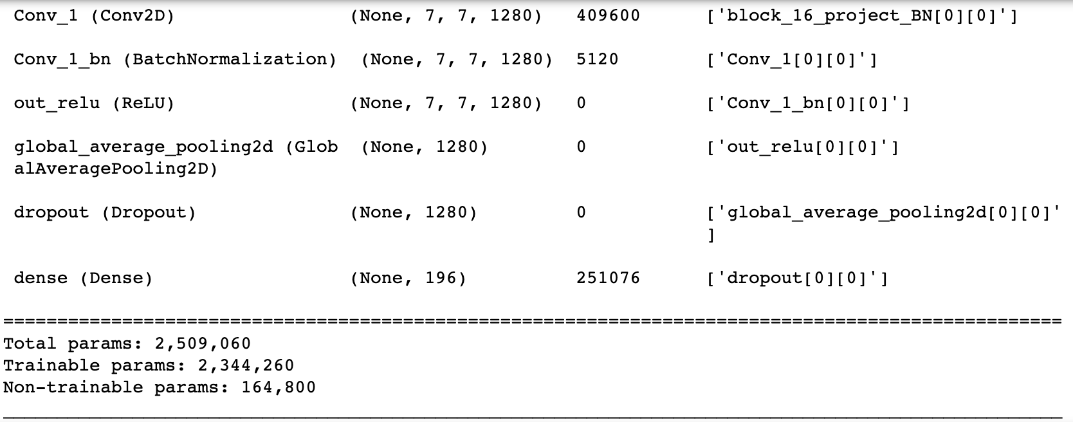

1. Training Accuracy: 0.9815 with loss: 0.1280.
2. Testing Accuracy: 0.7929 with loss: 0.7583.
3. This model have performed well and can be further more tune but its already taking 11h 4m 6s to run this.
4. **Using pre-trained models of coco ‘faster_rcnn_nas_coco_2018_01_28’**
5. This exercise is just to check how pre-trained model shows bbox for different set of images.
6. Model has been downloaded from [this](http://download.tensorflow.org/models/object_detection/faster_rcnn_nas_coco_2018_01_28.tar.gz) site and have used with car dataset.
7. Train Image prediction using coco pre-trained set:

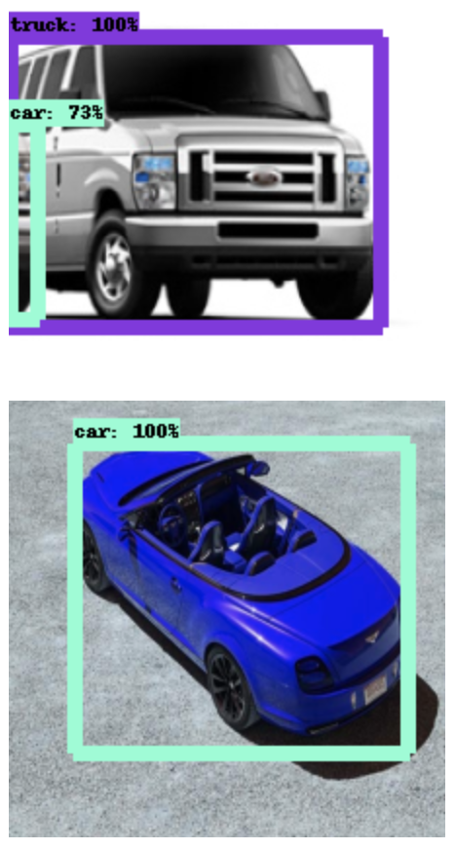 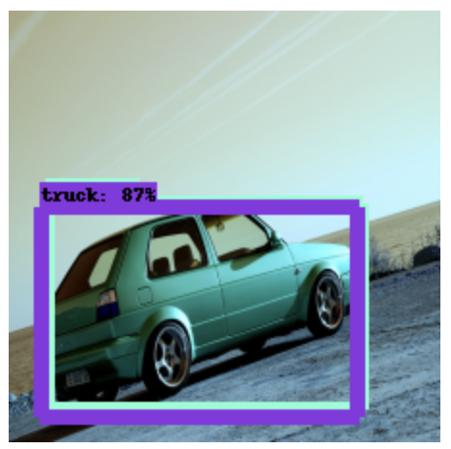

1. Test Image prediction using coco pre-trained set:

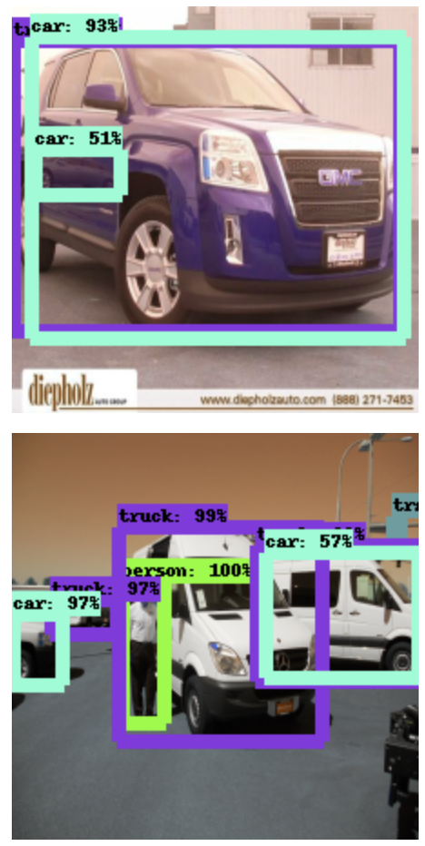 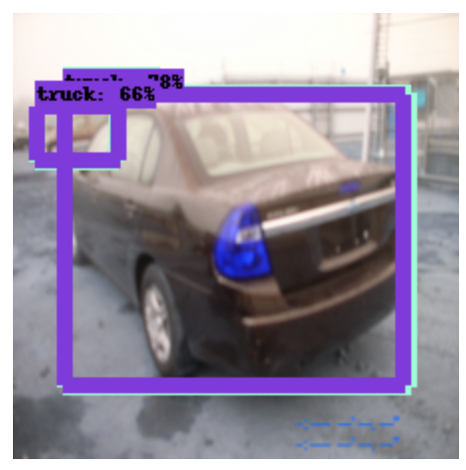

1. Boundary box and labelling understanding has been done via this model, now will train a faster rcnn model which will provide both bbox and class label.

# **Model evaluation**

Faster-RCNN model has been picked as final model that will be used as future prediction of class labels and boundary boxes of user provided images.

* Training dataset have 8144 train image that are categorised into 196 different car categories. So using ‘imgaug’ one of image augmenter, we will be creating another set of training images which will be clubbed with original training dataset images.

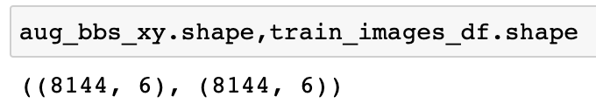

After clubbing both set into one final training dataset.

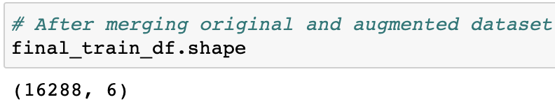

Visualising images from final dataset:

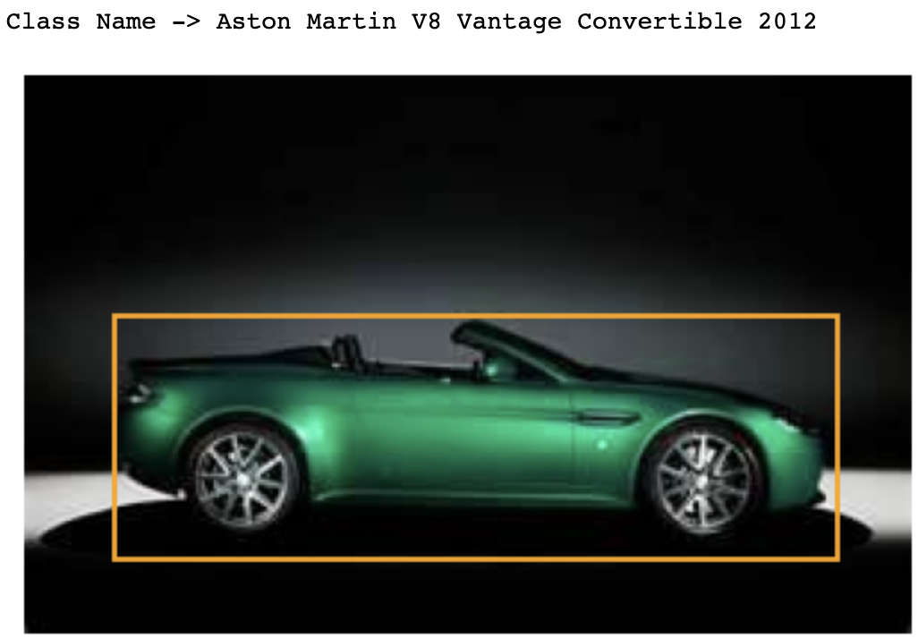 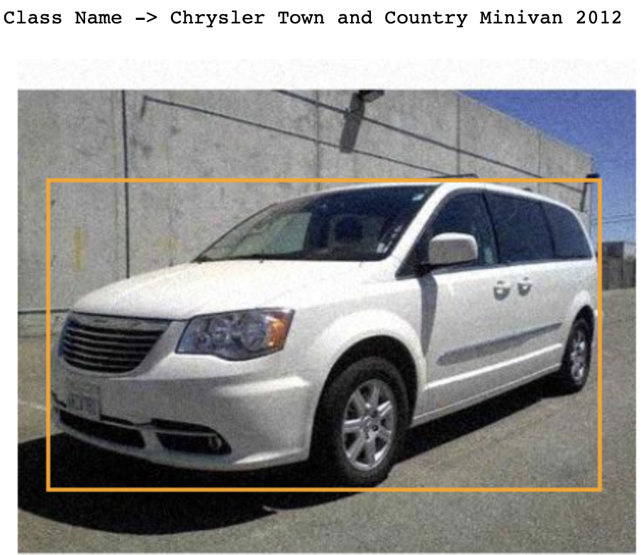

Final dataset will be pre-processed for modelling. Pre-processing will include scaling, resizing, bbox updating and after that converting images to array format.

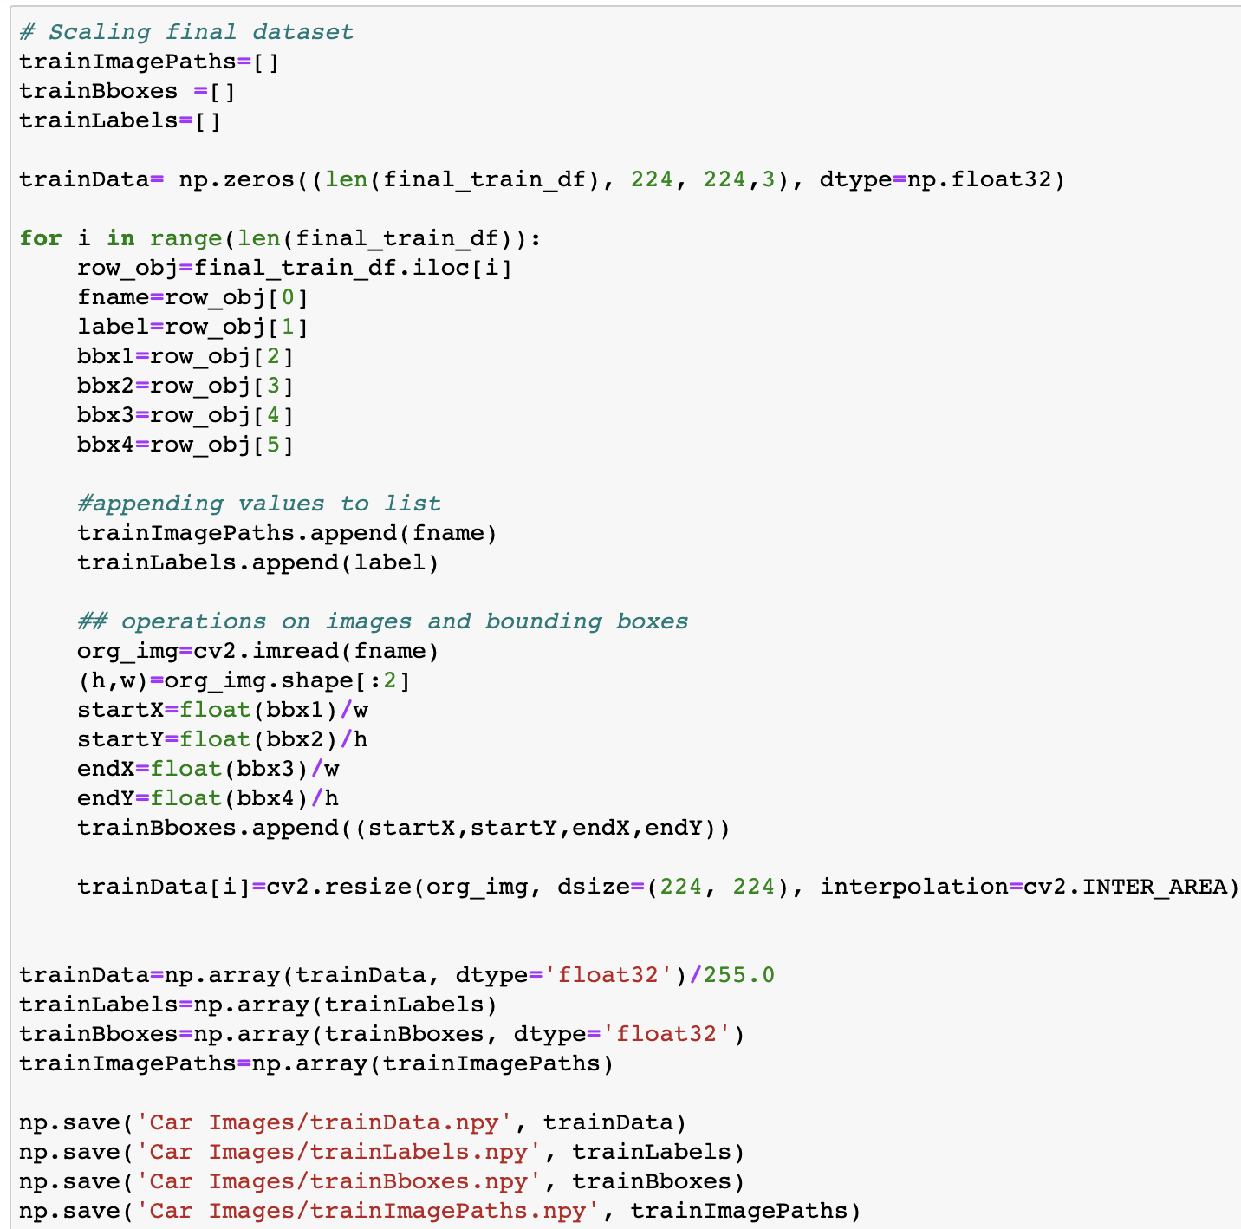

On hot encoding will be performed over labels using ‘LabelBinarizer’.

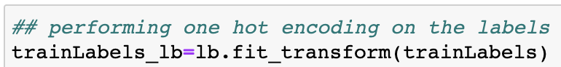

Printing shapes of all train dataset.

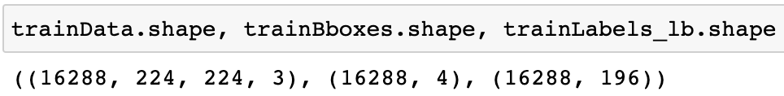

* Testing dataset have 8041 test image that are categorised into 196 different car categories.

Test dataset will be pre-processed for modelling. Pre-processing will include scaling, resizing, bbox updating and after that converting images to array format.

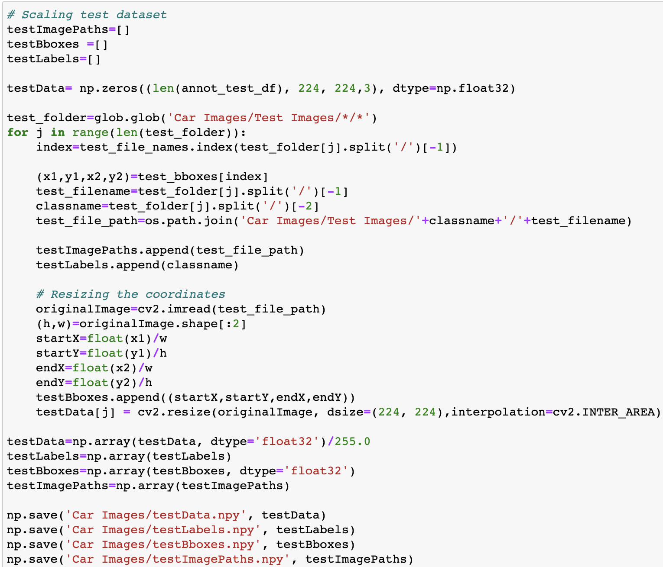

On hot encoding will be performed over labels using ‘LabelBinarizer’.

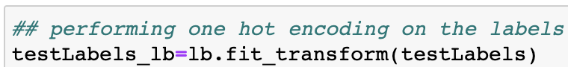

Printing shapes of all test dataset.

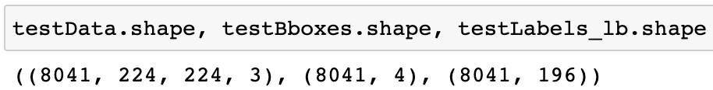

* As we will be using transfer learning with base model as MobileNetV2 with input_shape as (224,224,3) and weights as ‘ImageNet’, with first 70 layers as non-trainable.

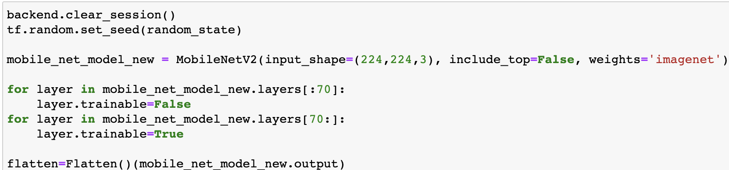

* Our model will be classifying bbox and class label, so will be plugging some extra dense layer to pre-existing model.

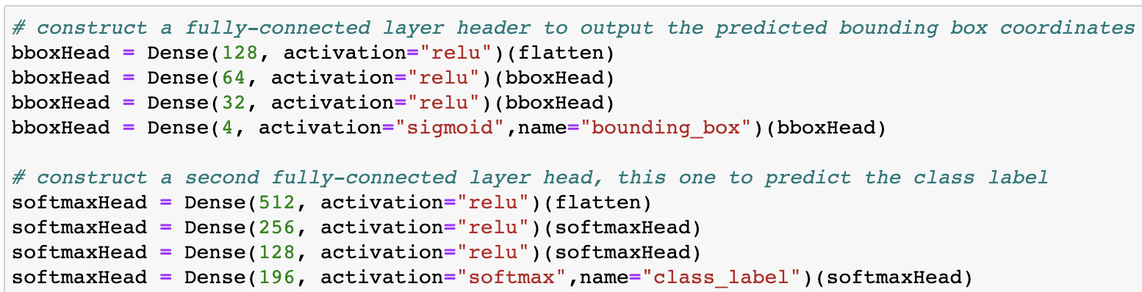

* As our model will predicting 2 things, i.e., bbox and labels, which will be numerical and categorical format, so our losses will contains both ‘mean_squared_error‘ and ‘categorical_crossentropy’.

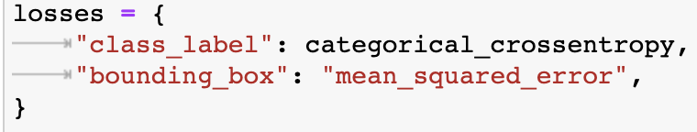

* Adam optimizer will be used with learning_rate as 0.001, metrics as ‘accuracy’.

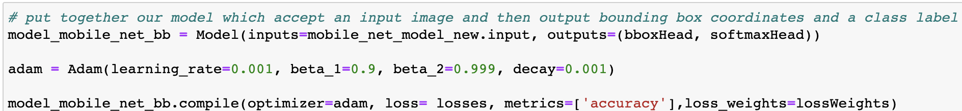

* Model summary trimmed:

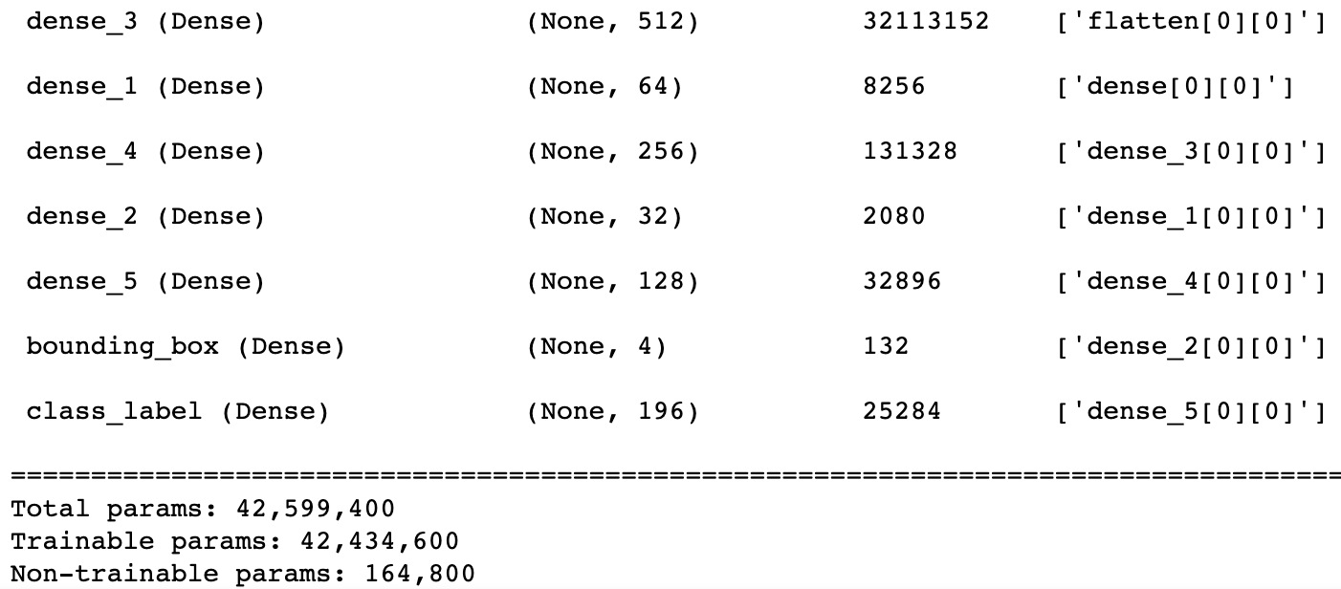

* Model training has taken 6h43m24s, where fit was provided with epochs as 50, batch_size as 50 but due to early stop, at 26 epochs only it got terminated.

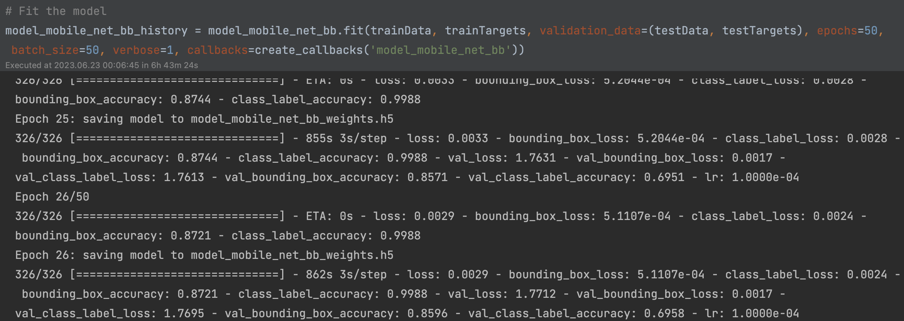

* Training Accuracy: bounding_box -> 0.8721 and class_label -> 0.9988.
* Testing Accuracy: bounding_box -> 0.8596 and class_label -> 0.6958.
* Model has been saved using pickle and keras save.
* Now let’s visualise loss for bbox, class_label and total loss.

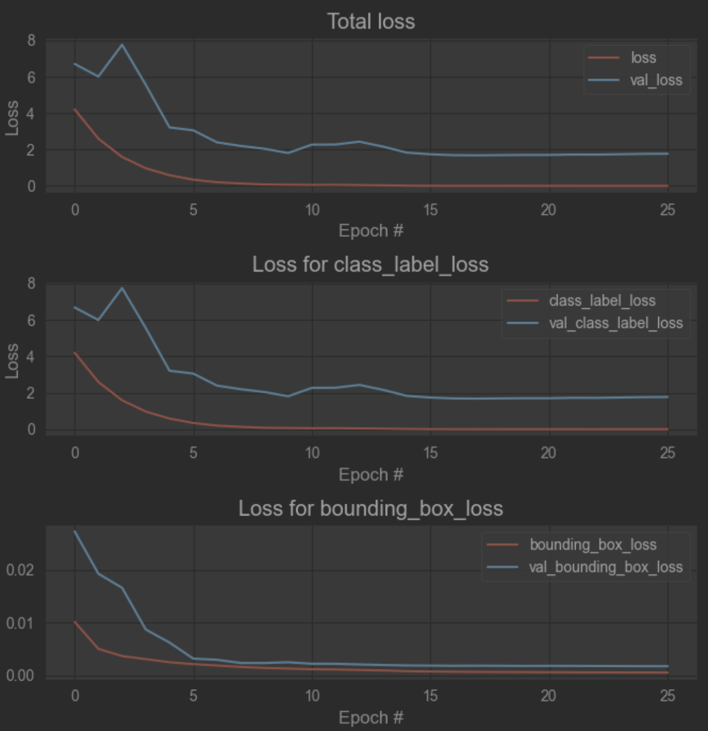

* Now let’s visualise accuracy for bbox and class_label.

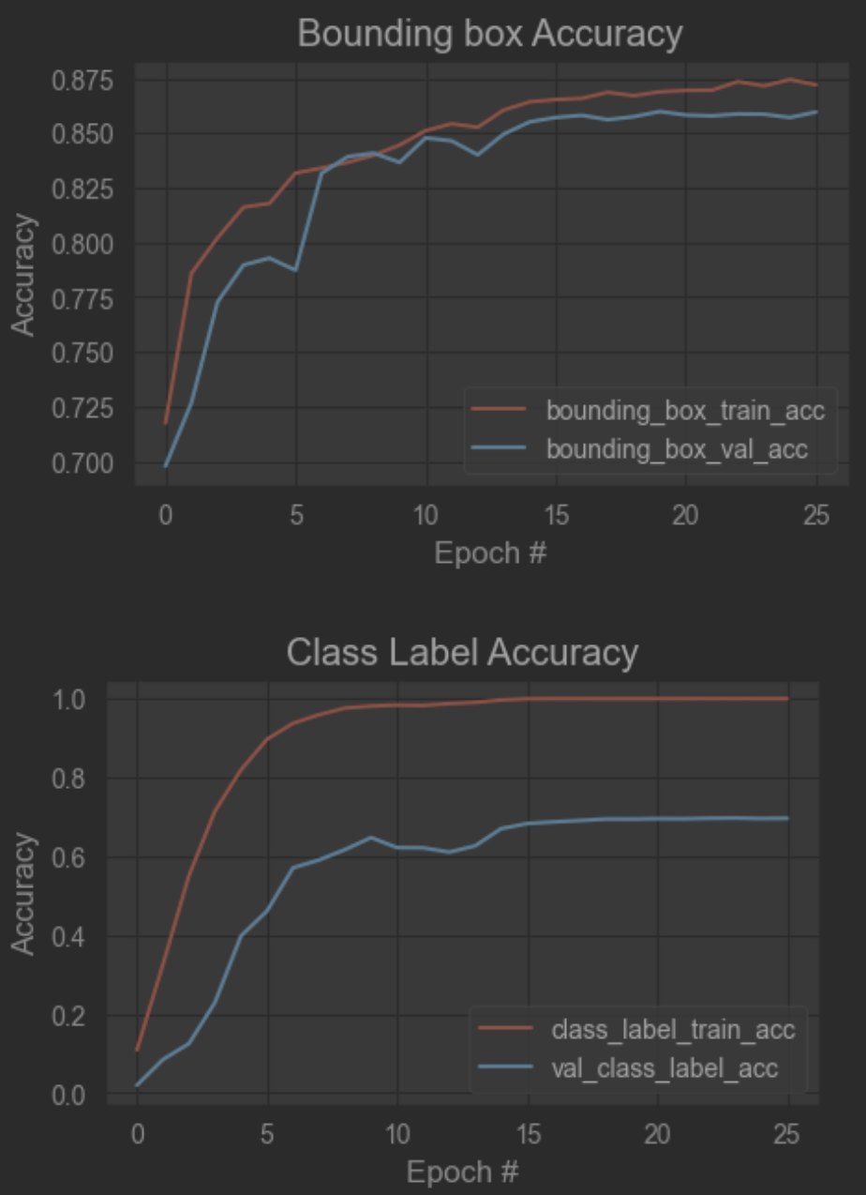

* Created a predict function which will load image from path, then resize, scale and convert to array. This function will use save model to predict bbox and label. This function will print image with bbox and label name on image and also plot a graph for total top 5 predictions.

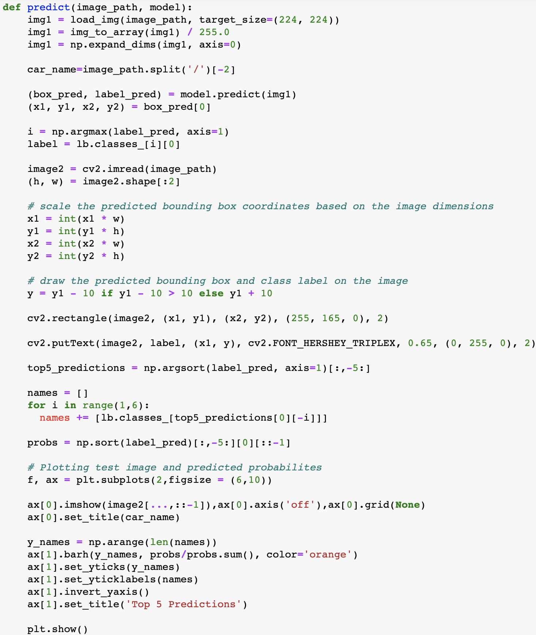

* Visualising image predictions:
* 'Car Images/Test Images/Land Rover LR2 SUV 2012/01116.jpg'

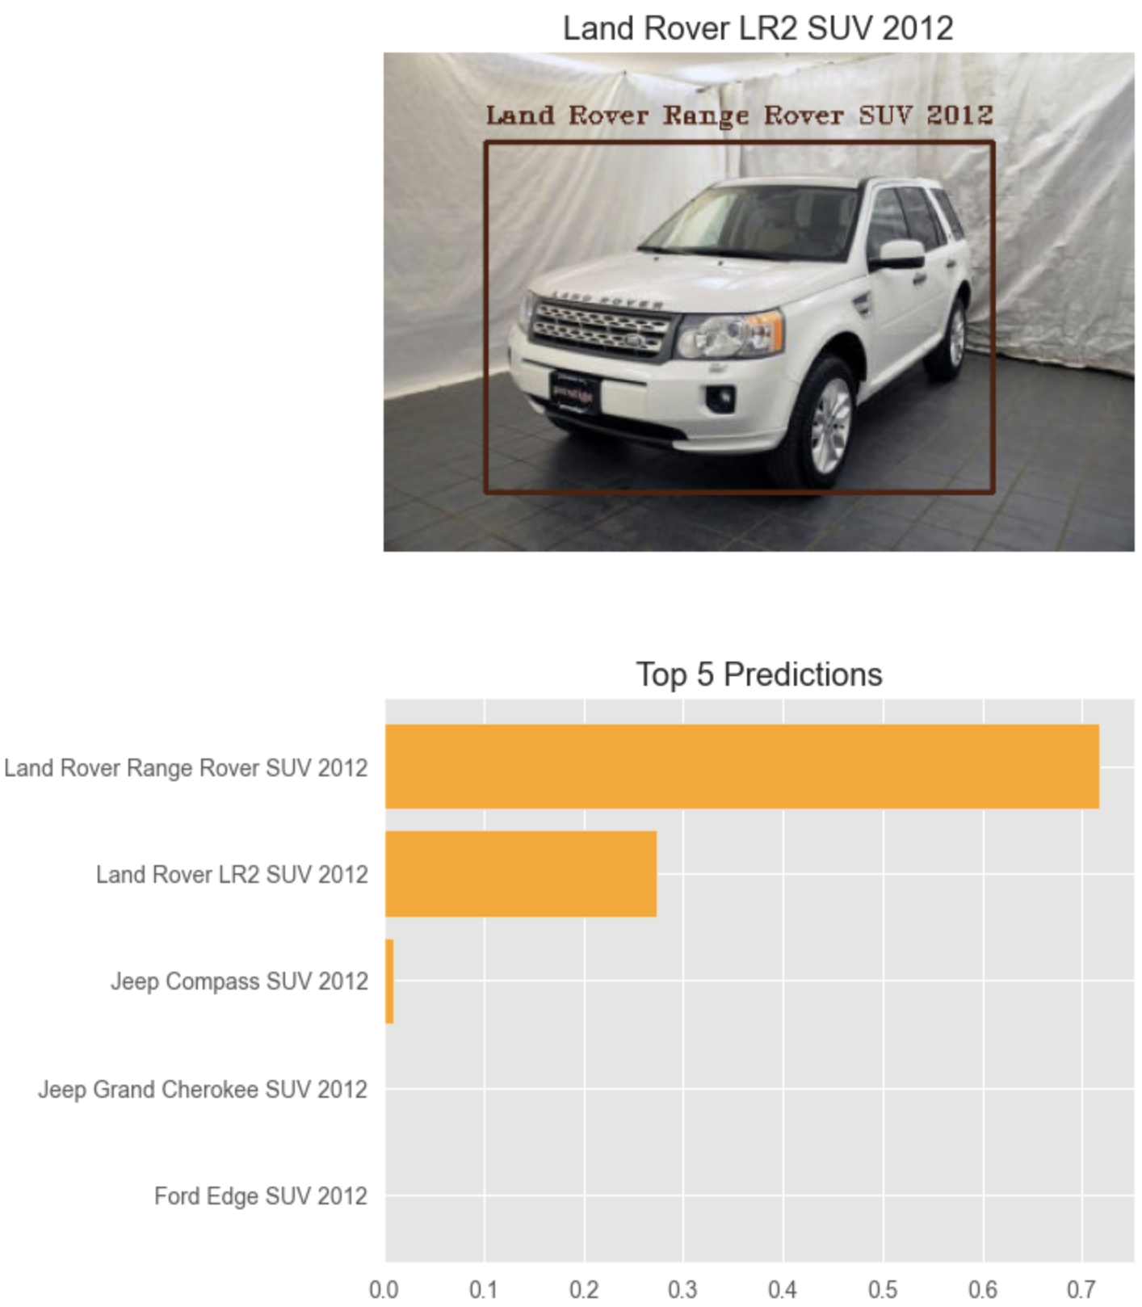

* ‘Car Images/Test Images/Mercedes-Benz C-Class Sedan 2012/01127.jpg’

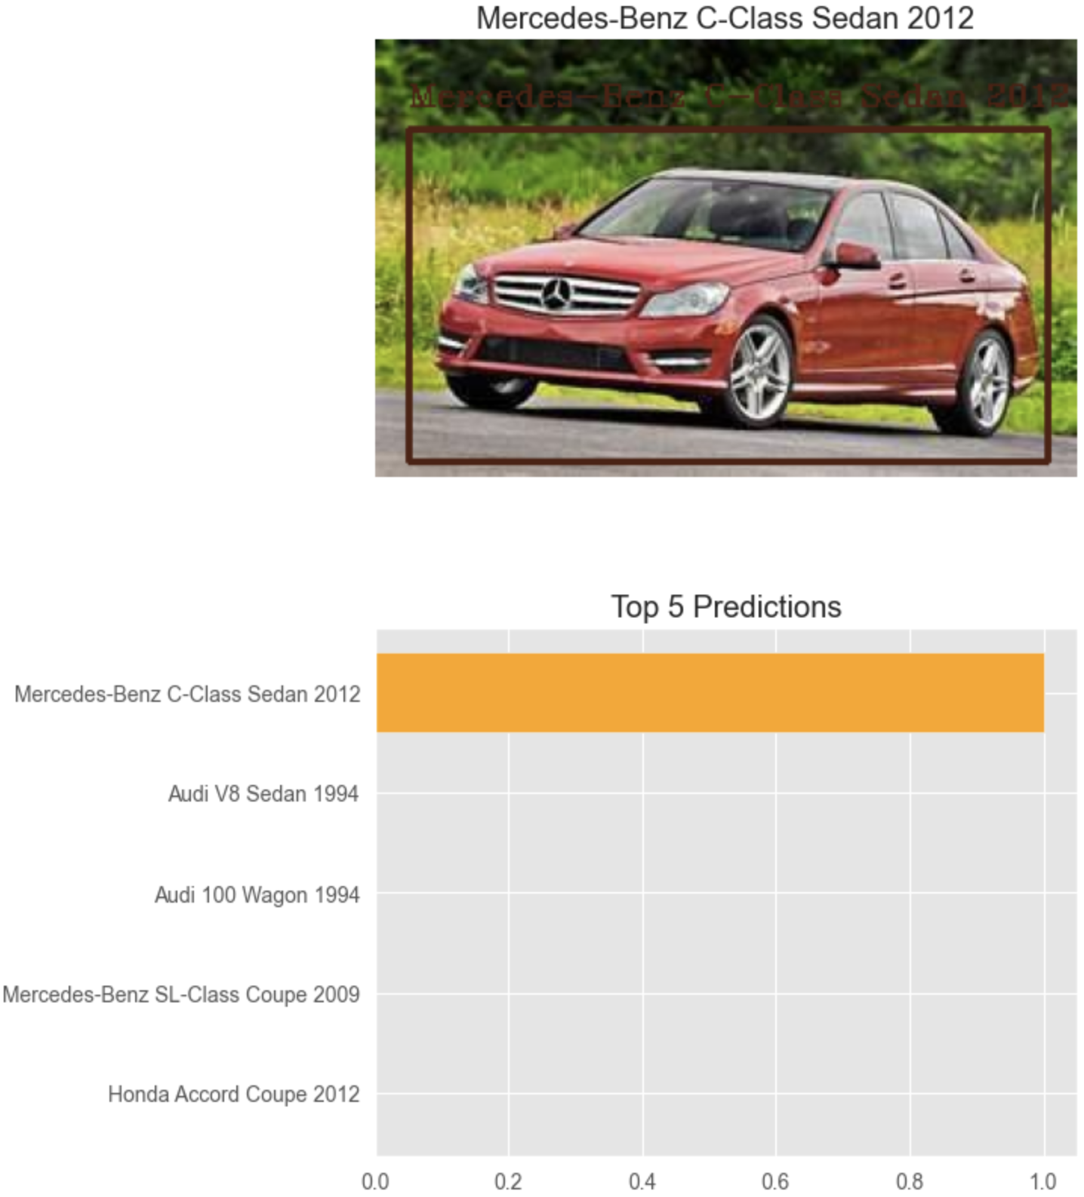

# **Python Flask and React Application**

As model has been saved using keras save model and pickle, so here we have created a backend API platform which will take image as input and provide the bbox and label over image and label as text also.

Loading models and label encoder class.

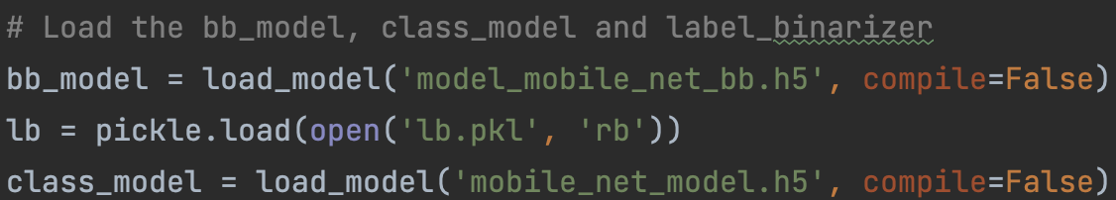

Currently there are 2 endpoints in FLASK:

* '/predict_label' POST endpoint:

This is a POST endpoint which will take image as an input and will return predicted label for the image as JSON format.

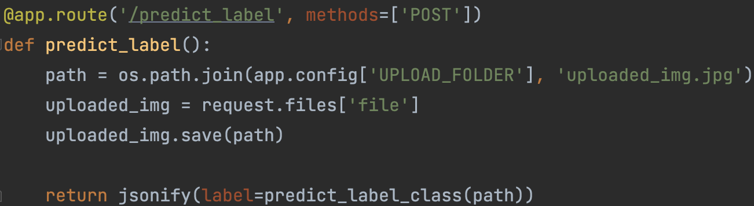

* '/predict_bbl' POST endpoint:

This is a POST endpoint which will take image as an input and will return edited image which will be having bbox and label over image.

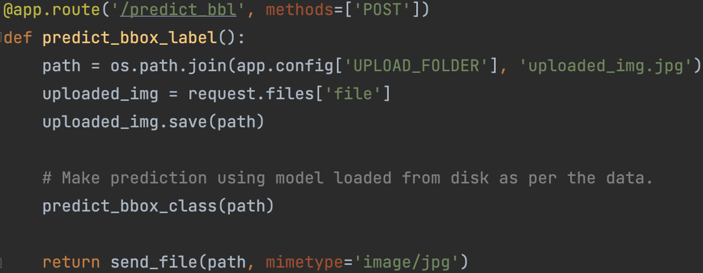

React application has been created which will be taking image from user and after executing and calling endpoints will be showing result to the user in UI.

Endpoint calls from react application:

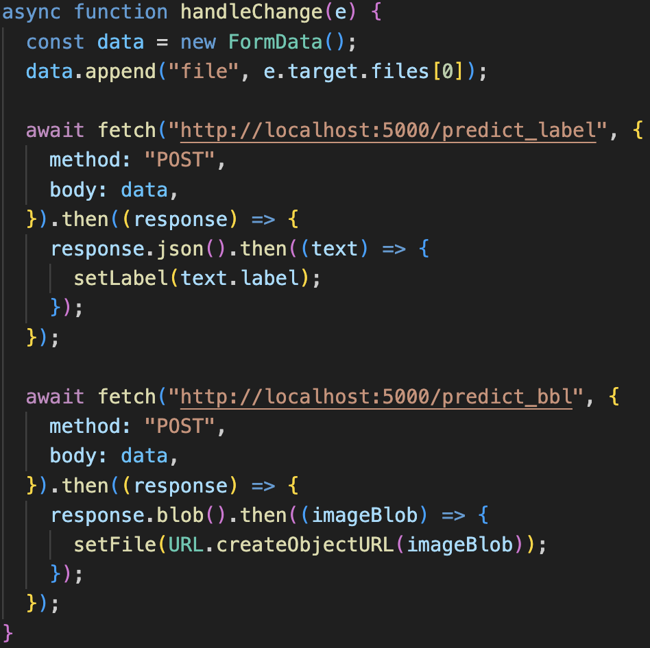

UI pages:

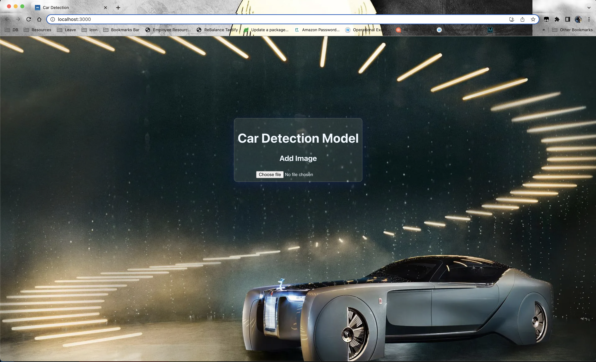

Once user has uploaded the image, it will shows predicted details in image.

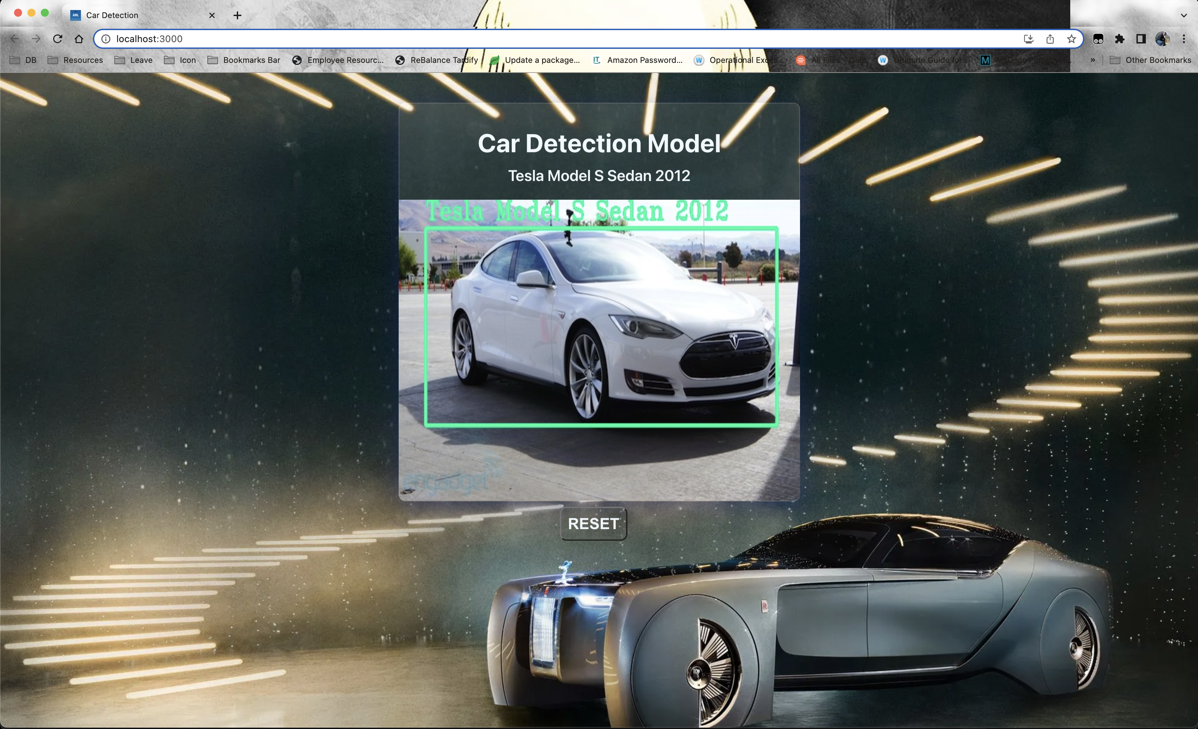

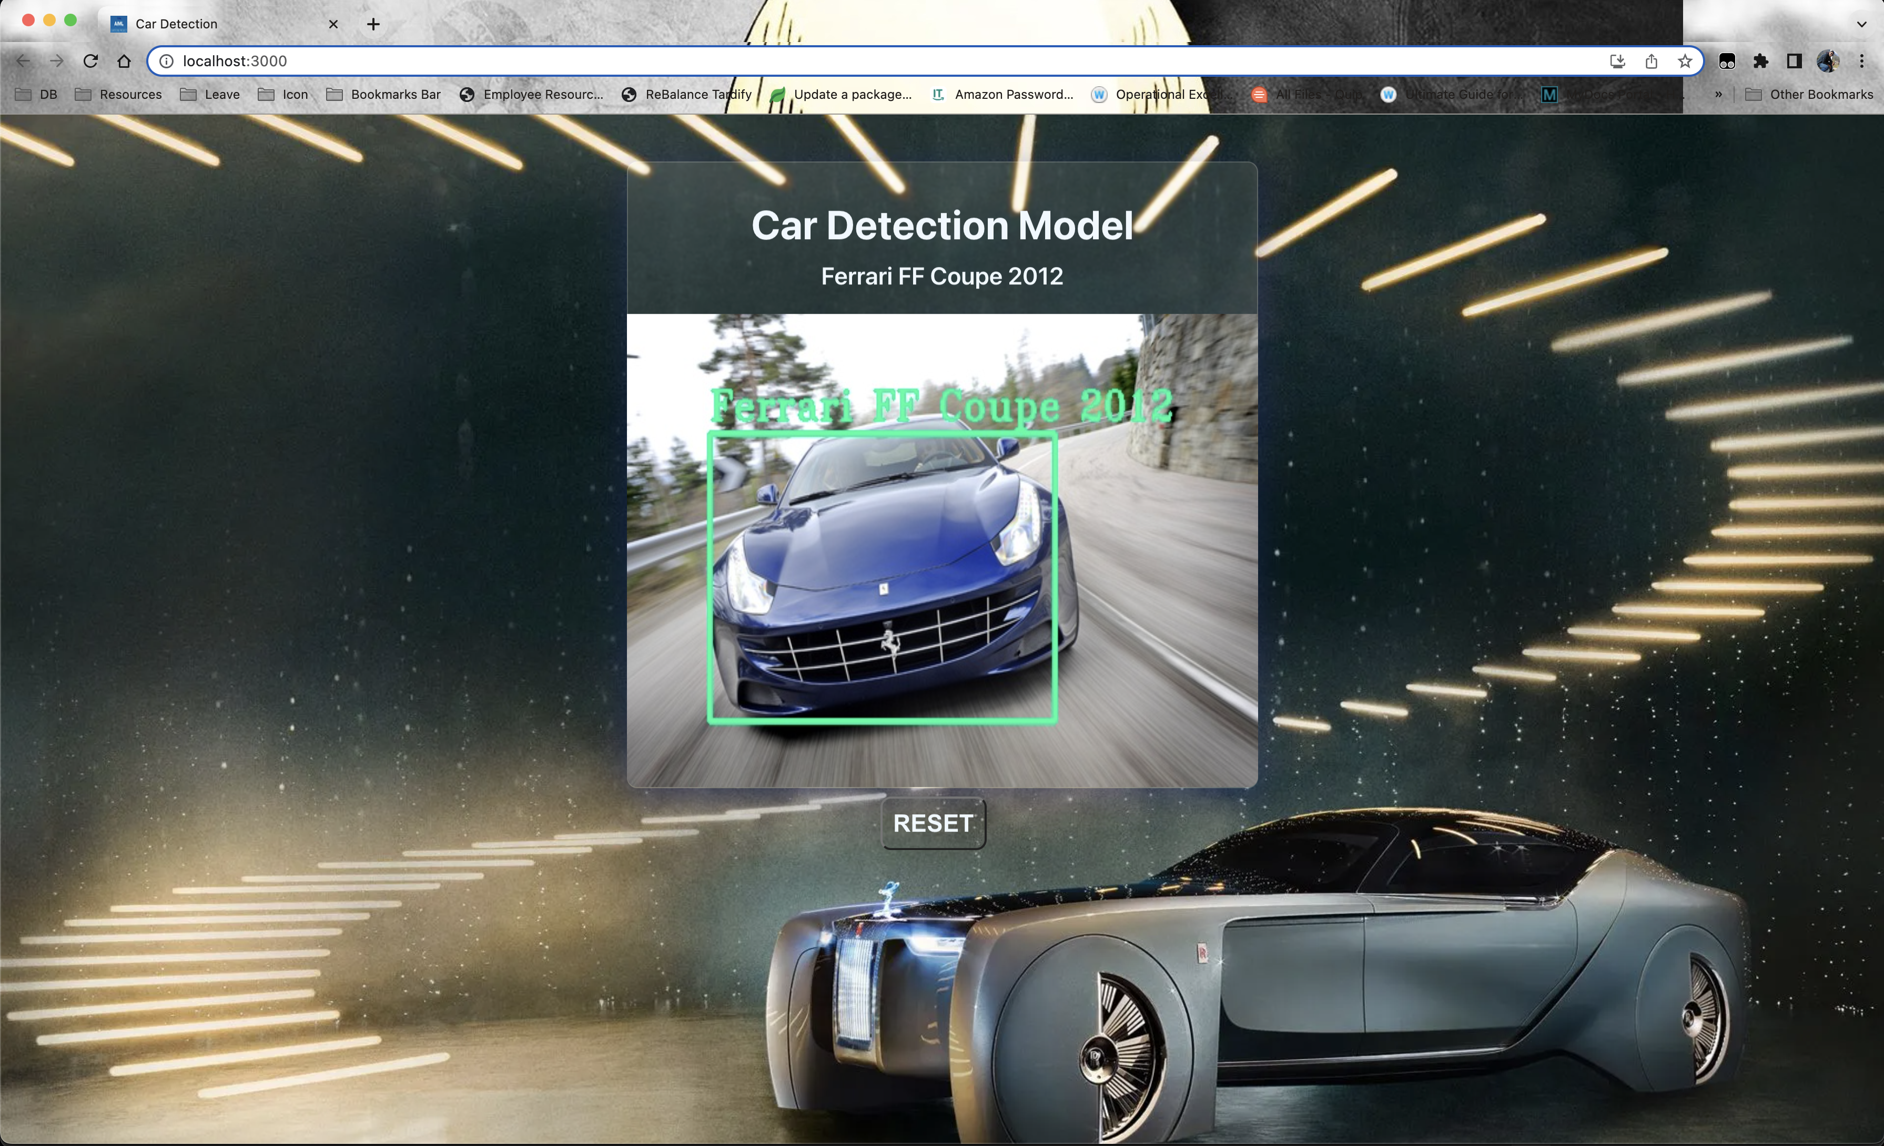

# **Comparison to benchmark**

In this model processing we have 2 models which have provided good accuracy but can be much better after some iterations and all.

* Model-1 with transfer learning

In this model we got good training accuracy and testing accuracy as compare to other simple models. So after some iteration have increased test accuracy from 59% to 79%, which can still be increased by tuning some params. But this model already took 11h4m6s to get trained.

* Model-2 with Faster RCNN with transfer learning

In this model we also got good training accuracy and testing accuracy for both boundary box and class labels. After many iteration testing accuracy has been improved drastically from 20-25% to 69%, which still can be increased by tuning some params.

So after few adjustment have stopped model training as its taking much ample time to get executed.

Still we can make improvements with using higher GPU/TPU which can train model much faster where we can adjust, learning_rate, epochs, batch_size, layers and many more checks.

# **Closing Reflections**

In this process of car identification model using Computer Vision has provided many insights, learning, reporting and point to think and where to start.

While training model there were many limitation occurred because of which model accuracy was less for test dataset. In term of limitations, the main concern was the resource for training the model was not that much feasible. As we already know training model takes much ample time and because of which it was bit tedious task to make improvement via tuning some parameters or training with different pre-trained models.

In future via this dataset we can have many different tasks like, identifying vehicle number so that it can be used for some informative purpose, or checking cars via camera is the number plate is GOVT. approved or not and many other test cases can be achieved from this.

As we know training CNN models needs high GPUs/TPUs, higher dataset just example single image needs to be rotated, use different angles, different background images, several different lighting conditions and more.

So in future while making model training we need to make a good set of trainset, best resource capacity like Sagemaker, GoogleColab paid GPUs and other cloud providers. Once we are good with resources we can fine tune our models hyperparameter easily with changing different type of criteria of the specified used model.